

**Installing GTM and DataLayer on Some Other CMS**

**Squarespace:**

DataLayer Code - <https://docs.google.com/document/d/1fUUhq0esDc1o7n8J0RoFQIPi9N22FQk6KHEUfwvI2bw/edit?usp=sharing>

**Wix:-**

Available free modules



**Magento 2**

Free UA DataLayer Extension - <https://www.weltpixel.com/google-analytics-enhanced-ecommerce-tag-manager-magento-2.html>

Paid GA4 DataLayer Extension -

<https://www.weltpixel.com/google-analytics-4-ga4-with-gtm-support-for-magento-2.html>

**Prestashop -**

GTM Modules:-

Module 1 - <https://addons.prestashop.com/en/analytics-statistics/27146-premium-google-tag-manager.html>

Module 2 - <https://addons.prestashop.com/en/analytics-statistics/23806-google-tag-manager-enhanced-ecommerce-ga4-ua-pro.html>

**ClickFunnels -**

Install GTM - 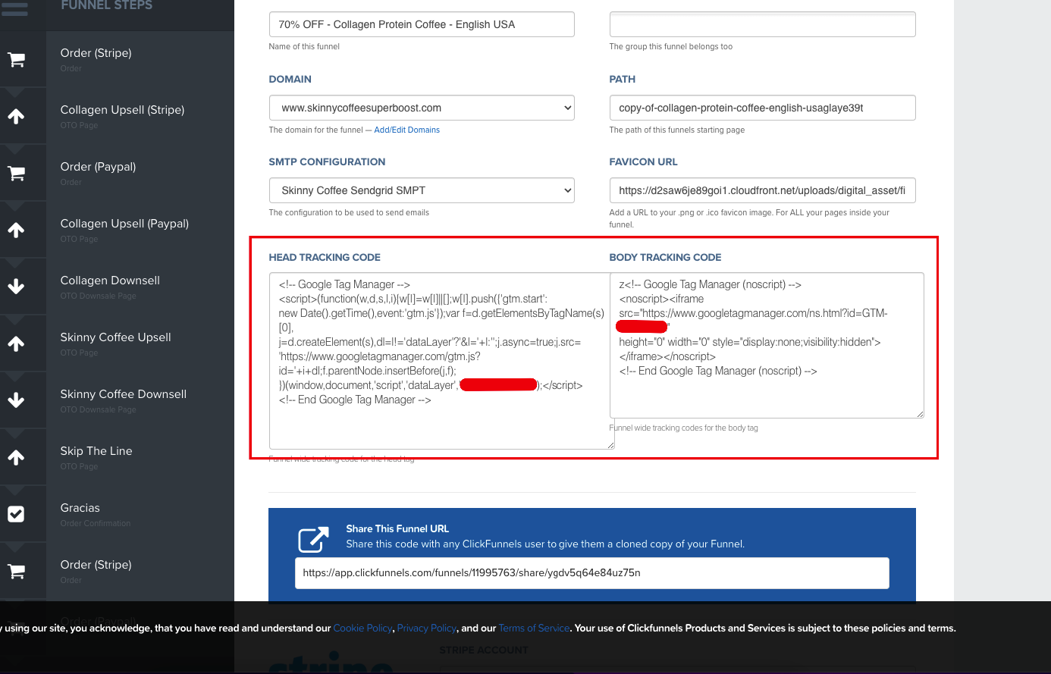

**Some other Partner integration options to install Tracking**

**Event setup tool, WordPress, Shopify, Wix, Squarespace, ClickFunnels, Kajabi**

**Will be discussed in class….**